• Curriculum Prompt Idea: "Argumentative Essay Prompt”*

Throughout these units (Grade 6: Units 2, 3, 4, and 5; Grade 7: Units 1, 3, 5, and 6; Grade 8: Units 2, 3, 4, and 5), you have read about individuals who faced difficult challenges and overcame adversity through courage, perseverance, hope, and determination.

Write an argumentative essay that answers the following question:

Which character trait is most important for overcoming adversity?

Develop a clear claim and support your argument with evidence from one HMH text (such as The Breadwinner, A Schoolgirl’s Diary from I Am Malala, Life Doesn’t Frighten Me Poem, Salva’s Story, and From Narrative Of the Life of Frederick Douglas ) and at least one biography or informational article read on myON. Explain how the evidence supports your claim and address at least one counterclaim before concluding your essay.

Your essay should include:

An engaging introduction with a clear thesis statement

At least three body paragraphs

Relevant text evidence from both sources

Analysis explaining how the evidence supports your claim

A counterclaim and rebuttal

A strong conclusion that reinforces your argument

Essential Question:
What personal qualities help people overcome adversity and achieve their goals?

Writing Standards

6W1 / 7W1 / 8W1 – Write Arguments

Write arguments to support claims with clear reasons and relevant evidence.

Introduce claim(s), acknowledge alternate or opposing claims, organize reasons and evidence logically, use credible evidence from texts, and provide a concluding statement.

6W2 / 7W2 / 8W2 – Write Informative/Explanatory Texts

Develop a topic with relevant facts, definitions, quotations, and examples while using appropriate transitions and precise language.

6W4 / 7W4 / 8W4 – Produce Clear and Coherent Writing

Produce writing appropriate to task, purpose, and audience.

6W5 / 7W5 / 8W5 – Develop and Strengthen Writing

Plan, revise, edit, rewrite, and strengthen writing with guidance and support.

6W9 / 7W9 / 8W9 – Draw Evidence from Literary and Informational Texts

Draw evidence from literary and informational texts to support analysis, reflection, and research.

Reading Standards

6R1 / 7R1 / 8R1 – Cite Textual Evidence

Cite strong and thorough textual evidence to support analysis and inferences.

udents use quotations and details from multiple texts to justify their argument.

6R2 / 7R2 / 8R2 – Determine Themes and Central Ideas

Determine a theme or central idea and analyze its development throughout a text.

6R3 / 7R3 / 8R3 – Analyze Individuals, Events, and Ideas

Analyze how individuals, events, or ideas develop and interact throughout a text.

6R9 / 7R9 / 8R9 – Compare Multiple Texts

Analyze how two or more texts address similar themes or topics.

Learning Targets

Students will:

Develop and defend a clear argumentative claim.

Integrate evidence from literary and informational texts.

Analyze how evidence supports a claim rather than simply summarize.

Address a counterclaim and provide a rebuttal.

Produce a coherent multi-paragraph essay using appropriate transitions and academic language.

Synthesize ideas across multiple texts to answer the essential question:
"What personal qualities help people overcome adversity and achieve their goals?"

Grade 6th /Unit 2,3,4,5 | HMH (Books for Bucket) | MyOn (Same themed book)
Grade 6th: 2  Theme-"Never Give Up," | A Schoolgirl’s Diary from I Am Malala | What You Never Knew About Zendaya by Allen, Nafeesah    What You Never Kanew About Stephen Curry Allen, Nafeesah  Believe Me, I Never Felt a Pea! Loewen, Nancy  Frankly, I Never Wanted to Kiss Anybody!: The Story of the Frog Prince as Told by the Frog Loewen, Nancy    What You Never Knew About LeBron James Allen, Nafeesah
Grade 6th: 2 | Speech to the Young: Speech to the Progress-Toward Poem by Gwendolyn Brooks | Breaking Barriers by Hans Hetrick    Birmingham 1963: How a Photograph Rallied Civil Rights Support by Shelley Togas  Ann Fights for Freedom: An Underground Railroad Survival Story by Nikki Shannon Smith  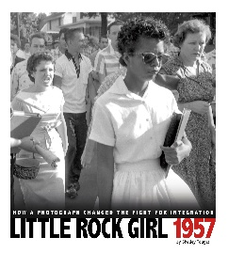  The Little Rock Nine: A Primary Source Exploration of the Battle for School Integration by Briann Krumm
Grade 6th: 2 | The First Day of School by R. V. Cassill | 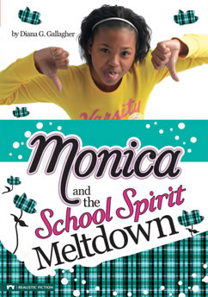  Monica and the School Spirit Meltdown by Dianna G. Gallagher  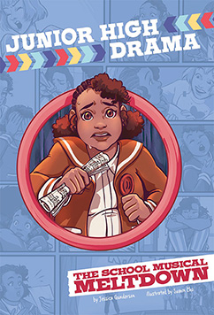  The School Musical Meltdown by Jessica Gunderson  Lunch Lines, Tryouts, and Making the Grade: Questions and Answers About School by Nancy Lowen  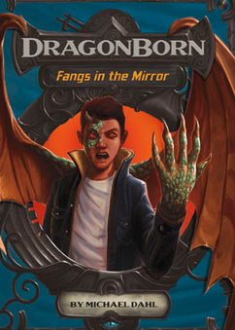  Fangs in the Mirror by Michael Dahl  The Man of Gold by Paul Weissburg
Grade 6th: 2 | from New Kid Graphic Novel by Jerry Craft | How the Leopard Got His Spots: The Graphic Novel by Rudyard Kipling    Kickoff Blitz by Blake Hoena  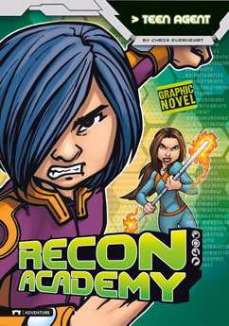  Teen Agent by Chris Everheart  Power Play by Jake Maddox
Grade 6th: 3  Theme-“Finding Courage” | from The Breadwinner Novel by Deborah Ellis | 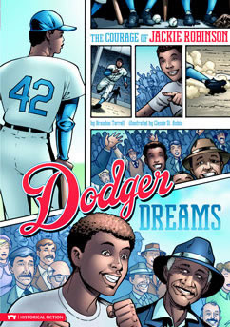Dodger Dreams: The Courage of Jackie Robinson By Brandon Terrell  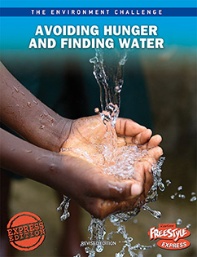  Avoiding Hunger and Finding Water (Express) Langley, Andrew  Smart Research Strategies: Finding the Right Sources Asselin, Kristine Carlson  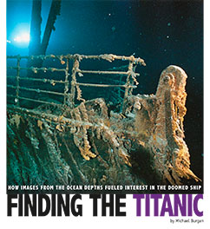  Finding the Titanic: How Images from the Ocean Depths Fueled Interest in the Doomed Ship Burgan, Michael  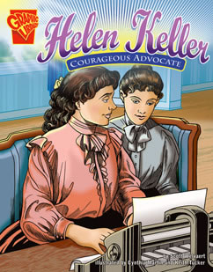  Helen Keller: Courageous Advocate Welvaert, Scott R.
Grade 6th: 3 | Life Doesn’t Frighten Me Poem by Maya Angelou | Stories of Women in the 1960s: Fighting for Freedom by Cath Senker  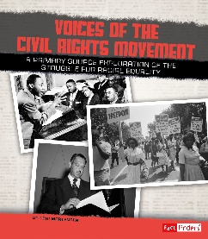  Voices of the Civil Rights Movement: A Primary Source Exploration of the Struggle for Racial Equality by Lori Mortenseten  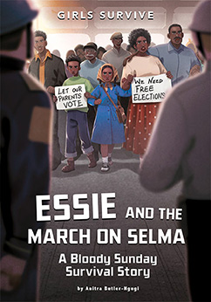Essie and the March on Selma by Anitra Butler- Ngugi  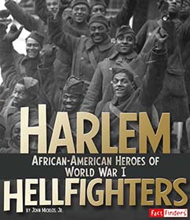  Harlem Hellfighters: African-American Heroes of World War I by John Mickolos
Grade 6th: 3 | Fears and Phobias Informational Text by kidshealth.org | The Great San Francisco Earthquake and Fire  Burgan, Michael  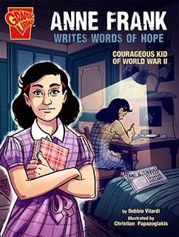Anne Frank Writes Words of Hope By Vilardi, Debbie    Stress Less: Your Guide to Managing Stress By Schwartz, Heather E.
Grade 6th: 3 | The Ravine by Graham Salisbury | Hawaii by Angie Swanson  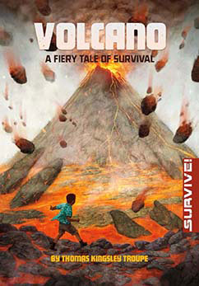  Volcano: A Fiery Tale of Survival by Thomas Kingsley Troupe  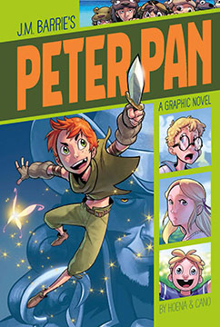  Peter Pan by J.M Barrie
Grade 6th: 3 | Embarrassed? Blame Your Brain Informational Text by Jennifer Connor-Smith | 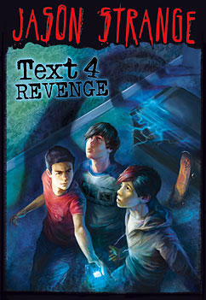Text 4 Revenge By Strange, Jason  Robots at Your Service: From the Factory to Your Home By Clay, Kathryn
Grade 6th: 3 | from Into the Air Graphic Biography by Robert Burleigh | X: A Biography of Malcolm X By Gunderson, Jessica  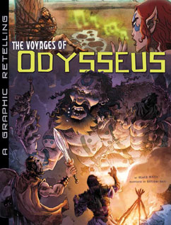  The Voyages of Odysseus: A Graphic Retelling By Hoena, Blake  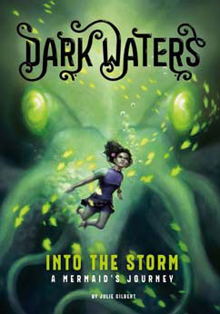Into the Storm: A Mermaid's Journey By Gilbert, Julie
Grade 6th: 4  Theme- Through an Animal's Eyes” | from Pax Novel by Sara Pennypacker | Speed, Strength, and Stealth: Animal Weapons and Defenses Rake, Jody Sullivan  Animals with No Eyes: Cave Adaptation Barnhill, Kelly    Let's Think About Animal Rights Parker, Vic  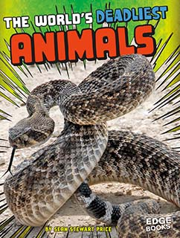  The World's Deadliest Animals  Price, Sean Stewart
Grade 6th: 4 | From Animal Snoops: The Wondrous World of Wildlife Spies Informational Text by Peter Christie | Text 4 Revenge By Strange, Jason  The Surprising World of Bacteria with Max Axiom, Super Scientist By Biskup, Agnieszka
Grade 6th: 4 | Animal Wisdom Poem by Nancy Wood | 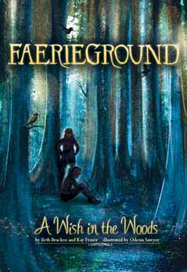A Wish in the Woods By Bracken, Beth  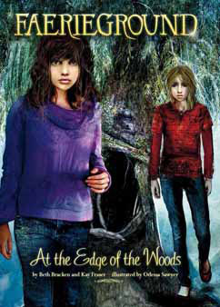  At the Edge of the Woods By Bracken, Beth
Grade 6th: 4 | The Last Wolf Poem by Mary TallMountain | 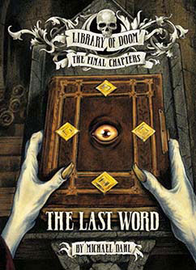The Last Word By Dahl, Michael
Grade 6th: 4 | Wild Animals Aren’t Pets by USA TODAY | 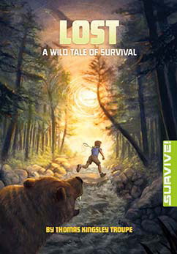Lost: A Wild Tale of Survival By Troupe, Thomas Kingsley  Arena of Monsters By Dahl, Michael
Grade 6th: 4 | Let People Own Exotic Animals by Zuzana Kukol | The Deadliest Animals on Earth By Shores, Erika L.  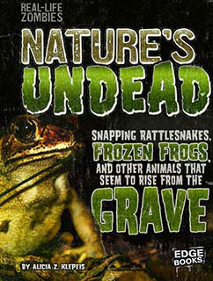  Nature's Undead: Snapping Rattlesnakes, Frozen Frogs, and Other Animals That Seem to Rise from the Grave By Klepeis, Alicia Z.    Exotic Cats By Mattern, Joanne
Grade 6th: 5  Theme- Surviving the Unthinkable” | Salva’s Story Documentary by POVRoseMedia | Buried in Rubble: True Stories of Surviving Earthquakes Collins, Terry  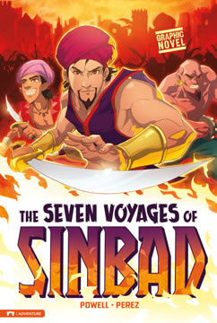  The Seven Voyages of Sinbad  Powell, Martin  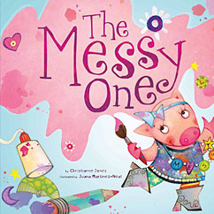  The Messy One Jones, Christianne C.  This or That Questions About the Desert Jaycox, Jaclyn
Grade 6th: 5 | Into the Lifeboat from Titanic Survivor Memoir by Violet Jessop | 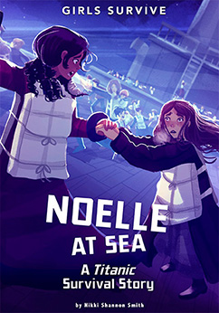Noelle at Sea: A Titanic Survival By Smith, Nikki Shannon
Grade 6th: 5 | from After the Hurricane by Rita Williams-Garcia
Grade 6th: 5 | from Ninth Ward Novel by Jewell Parker Rhodes | 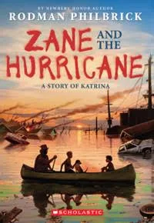Zane and the Hurricane: A Story of Katrina By Rodman Philbrick
7th Grade Units: 1,3,5,6  Theme- “Reality Check” | Books | The Future of Entertainment: From Movies to Virtual Reality  Eboch, M. M.
7th Grade Units: 1 | Mirror Image real and what’s not? Short Story by Lena Coakley | 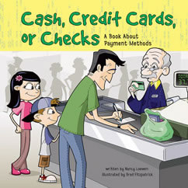Cash, Credit Cards, or Checks: A Book About Payment Methods Loewen, Nancy  Go for the Gold, Atalanta! McMullan, Kate    Design Diva Gurevich, Margaret  Power Play Maddox, Jake    Haunted Hotels Around the World Cooley Peterson, Megan
7th Grade Units: 1 | Not Everything real and what’s not? It Seems Article by Arnetta Carter | 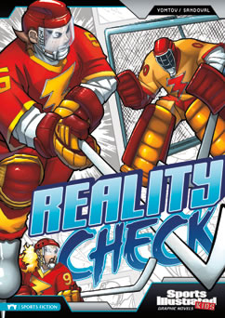Reality Check By Yomtov, Nel  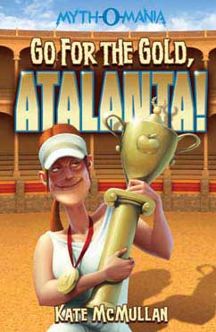Go for the Gold, Atalanta! By McMullan, Kate  Audrey Under the Big Top By Gunderson, Jessica
7th Grade Units: 1 | Two Legs or One? Folktale retold by Josepha Sherman | 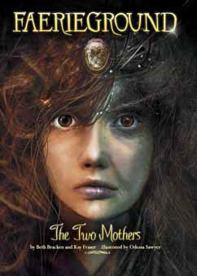The Two Mothers By Bracken, Beth  Scary Folktales By Kopp, Megan  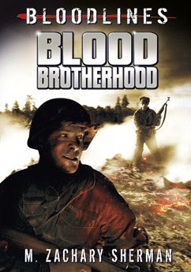Blood Brotherhood By Sherman, M. Zachary
7th Grade Units: 1 | The Song of Wandering Aengus Poem by W. B. Yeats | 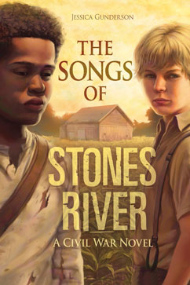The Songs of Stones River: A Civil War Novel By Gunderson, Jessica  Tharsis City: The Wonder of Mars By Collins, A.L.  The Odyssey: A Graphic Novel By Rodriguez, David  Khalid By Hudd, Emily
7th Grade Units: 1 | Eldorado Poem by Edgar Allan Poe | 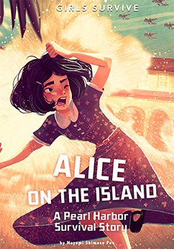Alice on the Island: A Pearl Harbor Survival Story By Shimose Poe, Mayumi    The Science Behind Wonders of the Sky: Aurora Borealis, Moonbows, and St. Elmo's Fire By Morey, Allan
7th Grade Units: 1 | from Monster: A Graphic Novel Graphic Novel by Walter Dean Myers, adapted by Guy A. Sims and illustrated by Dawud Anyabwile | 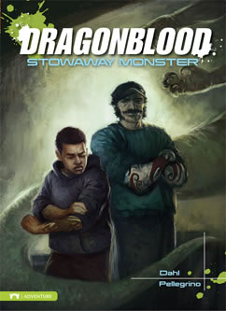Stowaway Monster By Dahl, Michael  Eye of the Monster By Dahl, Michael  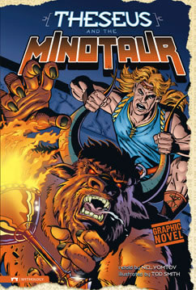  Theseus and the Minotaur Smith, Tod G
7th Grade Units: 3  Theme: The Terror and and Wonder of Space | Dark They Were, And Golden-Eyed by Ray Bradbury | 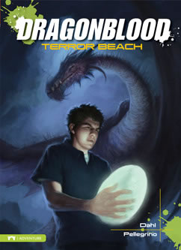Terror Beach Dahl, Michael
7th Grade Units: 3 | Martian Metropolis by Meg Thacher | Alexander Graham Bell and the Telephone Fandel, Jennifer
7th Grade Units: 3 | Challenges for Space Exploration by Ann Leckie | 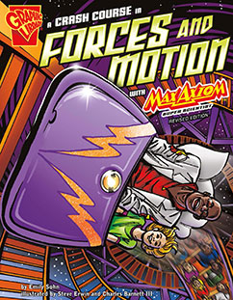A Crash Course in Forces and Motion with Max Axiom, Super Scientist Sohn, Emily
7th Grade Units: 3 | What If We Were Alone? By William Stafford | 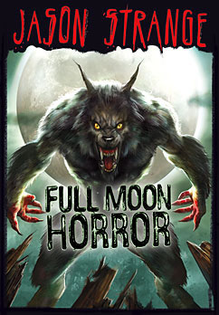Full Moon Horror Strange, Jason
7th Grade Units: 3 | Seven Minutes of Terror by NASA | 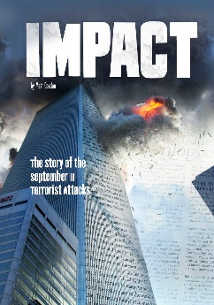  Impact: The Story of the September 11 Terrorist Attacks Doeden, Matt  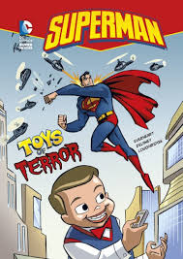  Toys of Terror By Everheart, Chris
7th Grade Units: 3 | Humans Need to Explore Outer Space Argument by Claudia Alarcón | 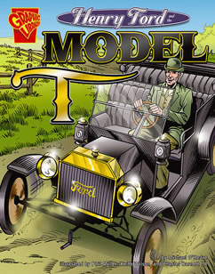Henry Ford and the Model T  O'Hearn, Michael
7th Grade Units: 3 | Let Robots Take to the Stars Based on the argument by Eiren Caffall | Aladdin and the Magic Lamp  Bowen, Carl
7th Grade Unit: 5  Theme: Game On! | Ball Hawk by Joseph Bruchac | 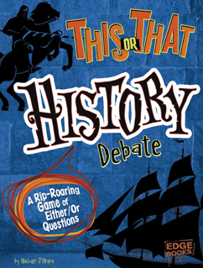This or That History Debate: A Rip-Roaring Game of Either/Or Questions O'Hearn, Michael  Fascinating Role-Playing Games Polydoros, Lori  Video Game Trivia: What You Never Knew About Popular Games, Design Secrets, and the Coolest Characters McCollum, Sean    The Truth About Life as a Pro Gamer O'Neal, Ciara  Freeriding and Other Extreme Motocross Sports by Smith, Elliott
:

7th Grade Unit: 5 | Get in The Zone: Psychology of Video-Game Design by Aaron Miller | Brutal Games: History's Most Dangerous Sports By Gitlin, Marty  Suzanne Collins: Author of the Hunger Games Trilogy  By Ferguson, Melissa
7th Grade Unit: 5 | It’s Not Just a Game!  By Lori Calabrese | 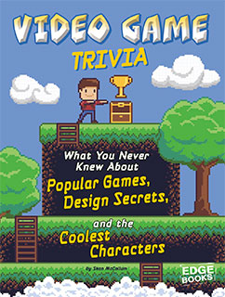Video Game Trivia: What You Never Knew About Popular Games, Design Secrets, and the Coolest Characters By McCollum, Sean  Stephenie Meyer: Author of the Twilight Series By Mortensen, Lori
7th Grade Unit: 5 | The Crossover by Kwame Alexander | 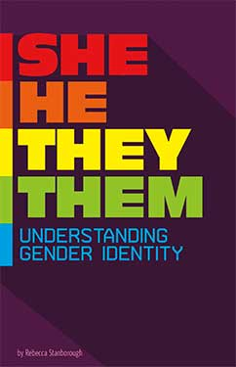She/He/They/Them: Understanding Gender Identity By Stanborough, Rebecca  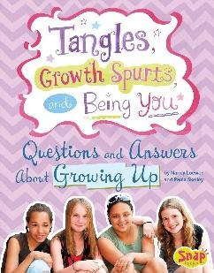  By Loewen, Nancy
7th Grade Unit: 5 | Double Double by J. Patrick Lewis | Nickolas Flux and the Salem Witch Trials  Goldilocks and the Three Vampires: A Graphic Novel  By Sutton, Laurie S.
7th Grade Unit: 6  Theme: Change Agents | Sometimes A Dream needs a Push by Walter Dean Myers | 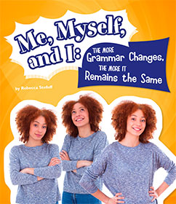Me, Myself, and I--The More Grammar Changes, the More It Remains Itself Stefoff, Rebecca  The Truth About Life as a YouTube Star by Cords, Sarah
7th Grade Unit: 6 | Craig Kielburger Reflects on Working Toward Peace  By Craig Keilburger | 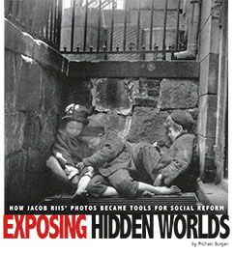Exposing Hidden Worlds: How Jacob Riis' Photos Became Tools for Social Reform By Burgan, Michael  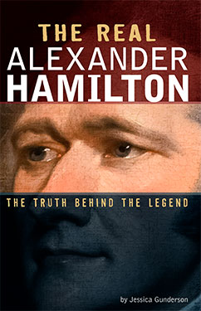  The Real Alexander Hamilton: The Truth Behind the Legend By Gunderson, Jessica  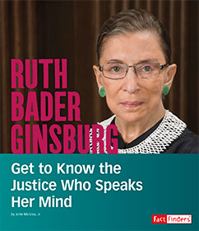Ruth Bader Ginsburg: Get to Know the Justice Who Speaks Her Mind By Micklos, Jr., John
7th Grade Unit: 6 | It Takes A Child by Judy Jackson | 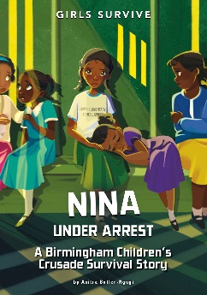  Nina Under Arrest: A Birmingham Children's Crusade Survival Story By Butler-Ngugi, Anitra
7th Grade Unit: 6 | A Poem For My Librarian, Mrs. Long by Nikki Giovanni | Little Rock Girl 1957: How a Photograph Changed the Fight for Integration Tougas, Shelley
7th Grade Unit: 6 | Frances Perkins and the Triangle Factory Fire by David Brooks | Ebola: How a Viral Fever Changed History  Lewis, Mark K.
7th Grade Unit: 6 | Ashes of Roses by Mary Jane Auch | 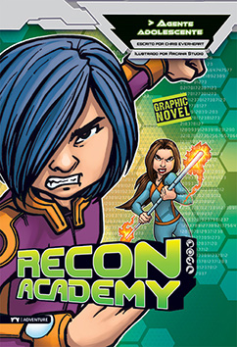Agente adolescente (Teen Agent)  Everheart, Chris

7th Grade Unit: 5 | Get in The Zone: Psychology of Video-Game Design by Aaron Miller |   Awesome Video Game Competitions by Lori Polydoros    Video Games Save the World by Heather E. Schwartz    Time for Action: The Inspiring Truth Behind Popular Adventure Video Games by Thomas Kingsley Troupe
7th Grade Unit: 5 | It’s Not Just a Game!  By Lori Calabrese | 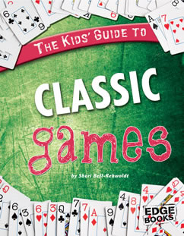  The Kids' Guide to Classic Games by Sherri Bell-Rehwoldt  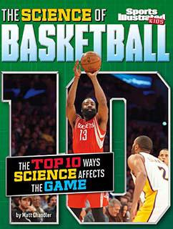  The Science of Basketball: The Top Ten Ways Science Affects the Game by Matt Chandler  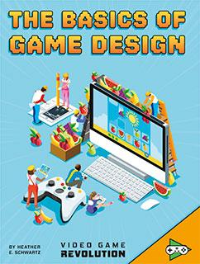  The Basics of Game Design by Heather E. Schwartz
7th Grade Unit: 5 | The Crossover by Kwame Alexander |   Football Fraud by Jake Maddox  Point-Blank Paintball by Scott Ciencen
7th Grade Unit: 5 | Double Double by J. Patrick Lewis |   Serena vs. Venus: How a Photograph Spotlighted the Fight for Equality by Danielle Smith-Allera  Basketball Breakdown by Jake Maddox
7th Grade Unit: 6  Theme: Change Agents | Sometimes A Dream needs a Push by Walter Dean Myers | Tuberculosis: How the White Death Changed History Lewis, Mark K.  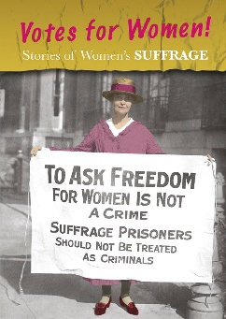 Stories of Women's Suffrage: Votes for Women! By Guillain, Charlotte  Little Rock Girl 1957: How a Photograph Changed the Fight for Integration Tougas, Shelley  Me, Myself, and I--The More Grammar Changes, the More It Remains Itself Stefoff, Rebecca  The Truth About Life as a YouTube Star by Cords, Sarah    The March on Washington: A Day That Changed America By Weston, Margeaux
7th Grade Unit: 6 | Craig Kielburger Reflects on Working Toward Peace  By Craig Keilburger | Stories of Women During the Industrial Revolution: Changing Roles, Changing Lives By Ben Hubbard  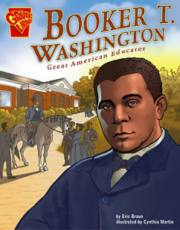  Booker T. Washington: Great American Educator By Margo Lundell  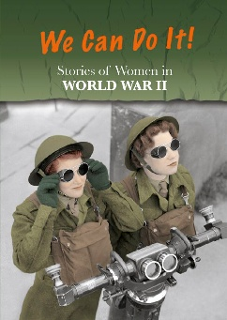  Stories of Women in World War II: We Can Do It! By Kathryn Clay  The Women Behind Rosie the Riveter: Working for the U.S. War Effort By Bonnie Hinman    Wangari Maathai: Get to Know the Woman Who Planted Trees to Bring Change By Lisa A. Crayton
7th Grade Unit: 6 | It Takes A Child by Judy Jackson | King of Pop: The Story of Michael Jackson By Collins, Terry  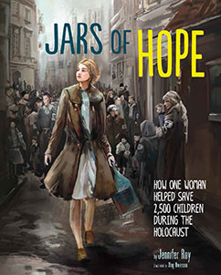  Jars of Hope: How One Woman Helped Save 2,500 Children During the Holocaust By Roy, Jennifer  Nina Under Arrest: A Birmingham Children's Crusade Survival Story By Butler-Ngugi, Anitra  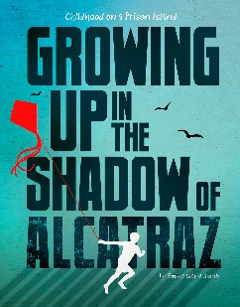  Growing Up in the Shadow of Alcatraz: Childhood on a Prison Island By Smith, Emma Bland  A Jar of Eyeballs By Dahl, Michael
7th Grade Unit: 6 | A Poem For My Librarian, Mrs. Long by Nikki Giovanni | 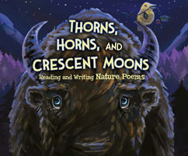  Thorns, Horns, and Crescent Moons: Reading and Writing Nature PoemsBy Fandel, Jennifer  Palabras, ingenio y maravilla: Escribe tu propio poema (Words, Wit, and Wonder: Writing Your Own Poem)  By Loewen, Nancy  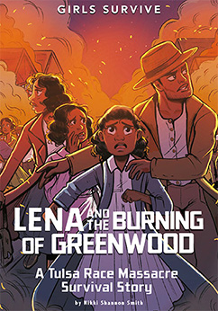  Lena and the Burning of Greenwood  By Smith, Nikki Shannon  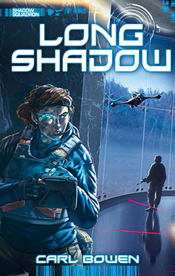  Long Shadow By Bowen, Carl
7th Grade Unit: 6 | Frances Perkins and the Triangle Factory Fire by David Brooks | The Triangle Shirtwaist Factory Fire By Gunderson, Jessica  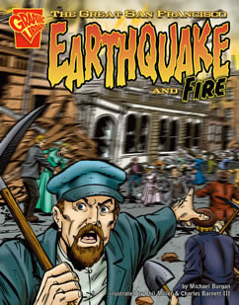  The Great San Francisco Earthquake and Fire By Burgan, Michael
7th Grade Unit: 6 | Ashes of Roses by Mary Jane Auch | 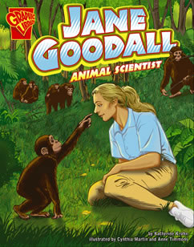Jane Goodall: Animal Scientist By Krohn, Katherine  Mary Read, Bold Pirate in Disguise B  The Attack on Pearl Harbor By Sutcliffe, Jane
8th Grade Unit :2,3,4,5  Theme: Thrill of Horror | What is the Horror Genre
8th Grade Unit :2 | The Tell’tale Heart | 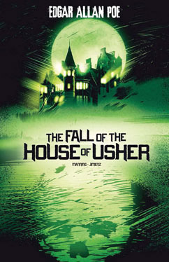The Fall of the House of Usher by Matthew K. Manning  The Murders in the Rue Morgue by Carl Bowen
8th Grade Unit :2 | The Monkey’s Paw | Cheetah and the Purrfect Crime By Sutton, Laurie S  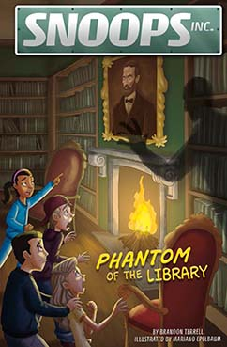  Phantom of the Library By Terrell, Brandon
8th Grade Unit :2 | From The Aeneid of Virgil
8th Grade Unit :2 | From Hades Lord of the Dead | Famous Ghost Stories of Asia by Jillian L. Harvey  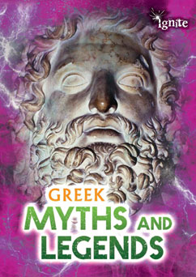  Greek myths and legends by Jilly Hunt
8th Grade Unit :3  Place We Call Home | Spirit Walking in the Tundra
8th Grade Unit :3 | The Book of Unknown Americans | 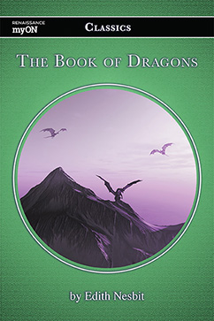The Book of Dragons By Nesbit, Edith
8th Grade Unit :3 | My Favorite Chapperones | The Big Push: How Popular Culture Is Always Selling By Wittekind, Erika    Pro Basketball's All-Time Greatest Comebacks By McCollum, Sean

8th Grade Unit :4  Fight For Freedom | From Narrative Of the Life of Frederick Douglas | Stories of Women in the 1960s: Fighting for Freedom By Senker, Cath  Into the West: Causes and Effects of U.S. Westward Expansion By Collins, Terry    Freedom Summer 1964: Turning Point for Voting Rights By Nnachi, Ngeri
8th Grade Unit :4 | The Drama Boy of Shiloh | Breaker Boys: How a Photograph Helped End Child Labor By Burgan, Michael  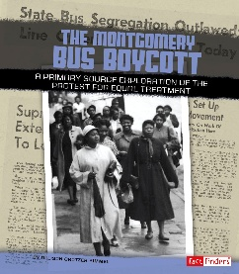  The Montgomery Bus Boycott: A Primary Source Exploration of the Protest for Equal Treatment By Kimmel, Allison Crotzer  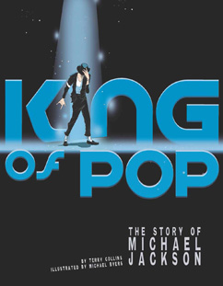  King of Pop: The Story of Michael Jackson By Collins, Terry
8th Grade Unit :4 | O Captain! My Captain! | 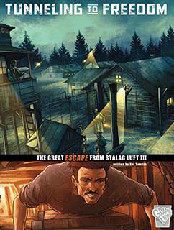Tunneling to Freedom: The Great Escape from Stalag Luft III By Yomtov, Nel  The Presidency of Abraham Lincoln: The Triumph of Freedom and Unity By Nardo, Don
8th Grade Unit :4 | Harriet Tubman: Conductor on the Underground Railroad | The First Amendment: Freedom of Speech and Religion By Micklos Jr., John  Freedom Riders: A Primary Source Exploration of the Struggle for Racial Justice By Schwartz, Heather E.  Birmingham 1963: How a Photograph Rallied Civil Rights Support By Tougas, Shelley  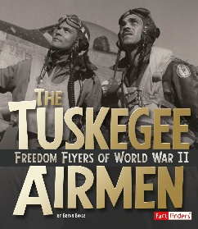  The Tuskegee Airmen: Freedom Flyers of World War II By Baker, Brynn
8th Grade Unit : 5
Finding Your Path
8th Grade Unit : 5 | The Debt We Owe to the Adolescent Brain | 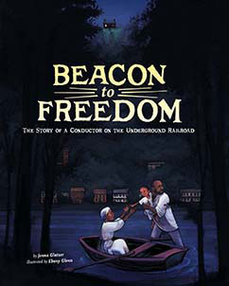Beacon to Freedom: The Story of a Conductor on the Underground Railroad By Glatzer, Jenna  American Indian Stories and Legends By Chambers, Catherine    The Science of Basketball: The Top Ten Ways Science Affects the Game By Chandler, Matt  Total Devastation: The Story of Hurricane Katrina By Burgan, Michael
8th Grade Unit : 5 | The Bronx Masquerade | 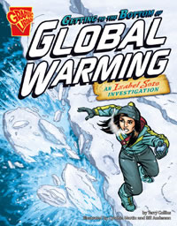Getting to the Bottom of Global Warming: An Isabel Soto Investigation By Collins, Terry    Quiet Confidence: The Shy Guide to Using Your Strengths By Kenney, Karen Latchana

